Primary 2 Newsletter
Term 4 2023

Dear Parent/Carer,
Welcome to Term 4. We very much look forward to this exciting final term. Please find below an overview of the intended learning for this term. If you have any questions, please do not hesitate to contact us. Thank you for your continued support, Primary 2 Team.
Literacy and English  This term, we are looking forward to writing about Pirates and the Lost Ship. We will be receiving letters from Captain Birdseye to provide the stimulus for creative, descriptive and functional writing.  Children will continue to develop their decoding skills and knowledge of sounds through their weekly group reader. Please continue to practise these at home where possible.  This term we begin with revising our Block 4 and Block 5 Edinburgh Literacy Rich Sounds before beginning Block 6 and 7 sounds.  Block 4 - Word building, focusing on ‘Magic e’ which makes short vowel sounds like ‘ah’ into long vowel sound ‘ay’.  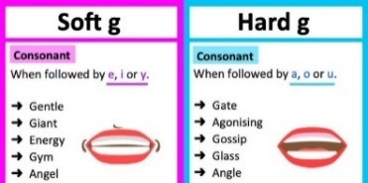  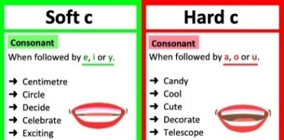  Block 5 – Word building, focusing on ‘soft c and soft g’.  Block 6 – Word building with two syllable, compound words e.g. aircraft, armpit, backfire, rainbow, blackbird and birdseed.  Block 7 – Word building with two syllables ending with ‘ing’ e.g. camping, blocking, looking, spending, bending, surfing, parking, talking and printing.  Admin  Outdoor learning sessions will continue to be held on a Tuesday. We will be participating in outdoor learning in all weathers. Please could children wear appropriate clothing.  P2A should continue to wear appropriate PE clothing on a Wednesday and P2B on a Thursday. Pupils will experience a snippet of various sports, particularly focusing on athletics in preparation for Sports Day.  As we plan to create pirate ship models, we would greatly appreciate if you could send in any washed ‘junk’ e.g. milk cartons, plastic bottles, cardboard boxes, tins etc that we could use. Thank you! | Numeracy and Mathematics  In numeracy, we will be continuing to focus on consolidating and extending our knowledge of addition and subtraction number facts within 100. We will also be consolidating our learning of early multiplication processes.  This term we will be learning about symmetry. We will be investigating lines of symmetry and creating symmetrical pictures. We will introduce fractions focusing on the concept that one half is one of two equal parts that together make up the whole number, amount, or object. We will also be revisiting coin recognition and simple money calculations to the value of £1.  Learning Across the Curriculum  Interdisciplinary Learning  This term we look forward to demonstrating our creativity through the context of Pirates. We will work co-operatively to investigate different materials to create pirate ships that float, explore a variety of media in art, listen to and create our own sea shanties, and act out various Pirate roles. Aargh!  Health and Wellbeing  This term we will be following RSHP, (Relationships, Sexual Health and Parenthood) learning progression. The intended learning involves naming parts of the body, the importance of privacy and people who care for me. For further information please find the curriculum in which we will be following;  https://rshp.scot/first-level/#tobegin  Much of this term will focus on a smooth transition in preparing your child for Primary 3. Children will have the opportunity during this term to meet their new teacher and familiarise themselves with their new environment.  Diary Dates  Thursday 27th April Sponsored Walk  Friday 26th May Sports Day  Tuesday 6th June Day or Night Workshop  Thursday 8th June P1/2 Fort Douglas School Trip  Wednesday 28th June Last Day of Term

