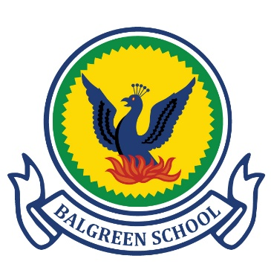
Fairtrade Cotton School Uniform

Our school will be introducing an ethical school uniform option made with Fairtrade Cotton and post-consumer recycled polyester, manufactured and supplied by Koolskools (see below).

WHY FAIRTRADE COTTON/RECYCLED POLYESTER UNIFORM?
- There is no difference in quality between Fairtrade cotton and normal cotton, but Fairtrade cotton farmers always receive a fair and sustainable payment for their crop. Their communities also receive a premium for projects such as building schools, hospitals, access to clean water and so on.

- Being “Fairtrade Cotton Certified” means that all parts of the manufacturing chain have been inspected and audited to ensure that practices such as child labour and enforced overtime/long working hours don’t exist.

- All the polyester in Koolskools-manufactured garments is GRS-certified, the highest recycled polyester clothing standard. The polyester will be post-consumer (eg recycled plastic bottles etc) recycled, lending the garments the strongest of planet-friendly credentials.
WHY KOOLSKOOLS
- Based in Southampton, over the past 10 years Koolskools have built an internationally renowned ethical clothing company, and work with schools all over the UK.

- Koolskools is the only school uniform provider in the UK offering a complete range of garments made with Fairtrade cotton and recycled polyester. Our research has proved that they offer quality, value-for-money garments that are double stitched, easy iron and durable.
- Koolskools also work with schools all over the UK offering presentations to children of all ages about ethical and fair trading. The idea is that if the school embraces school uniform made with Fairtrade cotton, then our students are given the opportunity to learn all about the ethical trading story behind it.

HOW TO ORDER
Go to the Balgreen Primary buying page on the Koolskools website on the following link - Balgreen Primary School – Koolskools or visit www.koolskools.co.uk and search for Balgreen Primary on the hompage then you can place your order.
There will be a flat delivery charge of £3.95, whether you order just one or multiple garments.
Orders will take a maximum of 10 working days (15 days during the busy June to September period) to turn around, from the date of order placement.

Early Summer 5% Discount On Koolskools Fairtrade Uniform
24 May - 13 June 2021

Koolskools have asked us to notify parents that they will be running an early summer 5% discount window for Fairtrade/ECO uniform from 24 May to 13 June inclusive.

Following their successful 5% discount offer in Summer 2020, designed to boost Fairtrade/ECO uniform sales after last year’s first lockdown, Koolskools are now offering a repeat in the wake of the third lockdown in the hope that parents will order ahead of this summer’s usual August rush!

